**Research summary:**

My research focuses on interfacing biology with microelectronics. In particular, my research group is interested in integrating functional biomaterials with micro- and nano- systems for sensing and actuation technologies. Throughout my academic career as a doctoral student and a postdoctoral fellow I have been exploring and developing portable micro-systems technology for the remote monitoring of complex samples in healthcare at the point-of-care and in environmental field settings. During this research, I devised engineered tools and strategies to overcome technological challenges of biological micro/nanoelectromechanical systems (Bio-M/NEMS) including design and fabrication, material and sensor basic characterization, device miniaturization, system-level integration, bioreceptor-electronics interface, and sensing of multivariable samples. In 2015 I joined the Department of Biomedical Engineering and as the Head of the [Nanobioelectronics Laboratory](http://nanobioelectronics.weebly.com) (NBEL) my research group will continue and expand this current line of work and investigate new engineering challenges in the field of analytical miniaturized devices related to micro- and nano-sensor development, functional biomaterial development and interface with electronics, micro-systems integration, sensing of complex systems, and real-world scenario-driven design and implementation. Current projects in my group include: real-time and mobile analysis of chemical and biological markers for personalized health monitoring, biosensing systems development and integration to provide “holistic” solutions for real-world use, and system-level mobile and network solutions for *in-vivo* and *in-vitro* clinical applications in the world of the Internet of Things.

C:\Users\HADARB~1\AppData\Local\Temp\vmware-Hadar Ben-Yoav\VMwareDnD\5859f964\Integrated_CLZ_LOC.emf 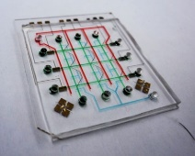 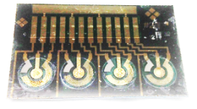

**Bio-MEMS and Lab-on-a-Chip Technologies Development**

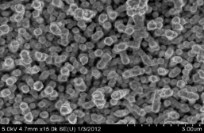 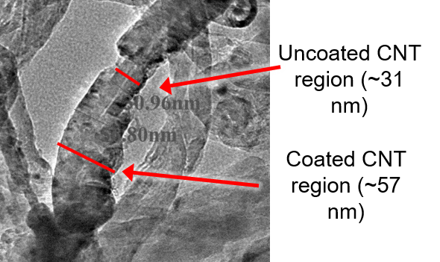

**Nanobioelectronic Interfaces**

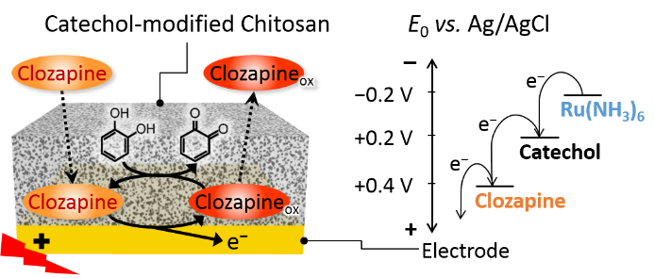 C:\Users\HADARB~1\AppData\Local\Temp\vmware-Hadar Ben-Yoav\VMwareDnD\05af54f1\Simulation_EC_2.emf

**Analytical Bio-Micro-/Nano-Systems**