Christopher J. Arnusch –IKI report

Research Activities
The Arnusch lab aims to positively impact the field of membrane science, water treatment and new materials in two distinct ways: i) by exploring and developing unconventional ways to improve membrane fabrication and modification using various printing techniques and ii) exploring and developing new materials including graphene-based materials.

We have made significant advances this past year especially with a novel material named “laser-induced graphene” (LIG). This material can now be generated on almost all carbon containing substrates. Notably, we discovered how to apply LIG on porous polymer membranes, as well as demonstrated numerous environmental applications. Seen below is the graphical abstract (from REF 34) for our most significant advance where LIG is fabricated on porous UF membranes, and these membranes are used as porous electrodes and display antifouling and antimicrobial action with applied voltage.

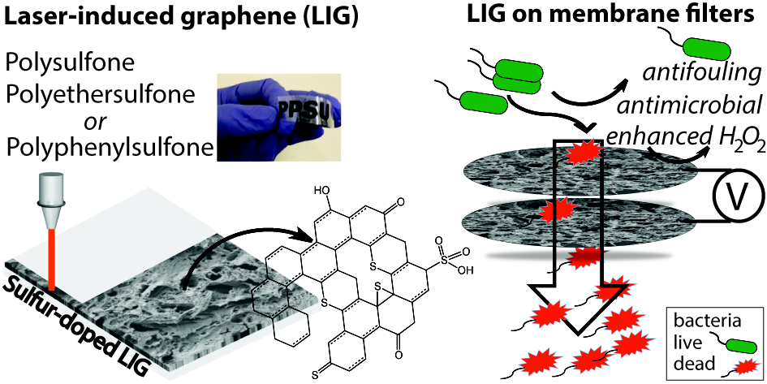

Publications
40. Luong, D.X.; Yang, K.; Yoon, J.; Singh, S.P.; Wang, T.; Arnusch, C.J.;. Tour, J.M.
Laser-Induced Graphene Composites as Multifunctional Surfaces. ACS Nano 2019, accepted in press. DOI: 10.1021/acsnano.8b09626.

39. Shtreimer Kandiyote, N.; Avisdris, T.; Arnusch, C. J. *, Kasher, R.* Grafted Polymer Coatings Enhance Fouling Inhibition by Antimicrobial Peptide on Reverse Osmosis Membranes. Langmuir 2019, DOI: 10.1021/acs.langmuir.8b03851.
38. Shtreimer Kandiyote, N.; Mohanraj, G.; Mao, C.; Kasher, R.*; Arnusch, C. J.* Synergy on Surfaces: Anti-Biofouling Interfaces using Surface-Attached Antimicrobial Peptides PGLa and Magainin-2. Langmuir 2018, 34 (37), 11147-11155.
37. Singh, S. P.; Rathinam, K.; Kasher, R.*; Arnusch, C. J.* Hexavalent chromium ion and methyl orange dye uptake via a silk protein sericin-chitosan conjugate. RSC Advances 2018, 8, 27027-27036.
36. Mohanraj, G.; Mao, C.; Armine, A.; Kasher, R.*; Arnusch, C. J.* Ink-Jet Printing-Assisted Modification on Polyethersulfone Membranes Using a UV-Reactive Antimicrobial Peptide for Fouling-Resistant Surfaces. ACS Omega 2018, 3 (8), 8752-8759.
35. Rathinam, K.; Singh, S. P.; Arnusch, C. J.*.; Kasher, R,* An environmentally-friendly chitosan-lysozyme biocomposite for the effective removal of dyes and heavy metals from aqueous solutions, Carbohydrate Polymers 2018, 199 (1), 506-515.
34. Singh, S. P.; Ramanan, S.; Kaufman, Y.; Arnusch, C. J.* Laser-Induced Graphene Biofilm Inhibition: Texture Does Matter. ACS Applied Nano Materials 2018, 1 (4), 1713–1720.
33. Chyan, Y.; Ye, R.; Li, Y.; Singh, S. P.; Arnusch, C. J.* Tour, J. M.* Laser-Induced Graphene by Multiple Lasing: Towards Electronics on Cloth, Paper and Food. ACS Nano 2018, 12 (3), 2176-2183.
32. Canwei, M.; Gunasekaran M.; Kandiyote, N.; Kasher, R.; Arnusch, C. J.* UV mediated attachment of short Arginine-Tryptophan antimicrobial peptides on reverse osmosis membrane surfaces inhibit Pseudomonas aeruginosa biofilm Desalination 2018, 431, 73-79.
31. Singh, S. P.; Li, Y.; Zhang, J.; Tour, J. M.*; Arnusch, C. J.* Sulfur-doped laser-induced porous graphene derived from polysulfone-class polymers and membranes ACS Nano 2018, 12 (1), 289–297.
30. Bernstein, R*.; Singer, C. E.; Singh, S. P.; Mao, C.; Arnusch, C. J.* UV initiated surface grafting on polyethersulfone ultrafiltration membranes via ink-jet printing-assisted modification Journal of Membrane Science 2018, 548, 73-80.
​
29. Rathinam, K.; Singh, S. P.; Li, Y.; Kasher, R.; Tour, J. M.*; Arnusch, C. J.* Polyimide derived laser-induced graphene as adsorbent for cationic and anionic dyes Carbon 2017, 124, 515-524.
28. Singh, S. P.; Li, Y.; Be’er A.; Oren, Y.; Tour, J. M.*; Arnusch, C. J.* Laser-Induced Graphene Layers and Electrodes Prevents Microbial Fouling and Exerts Antimicrobial Action ACS Applied Materials and Interfaces 2017, 9 (21), 18238-18247.
27. Li, Y.; Luong, D.X.; Zhang, J.; Tarkunde, Y. R.; Kittrell, C.; Sargunaraj, F.; Ji, Y.; Arnusch, C. J.*; and Tour, J. M.* Laser-Induced Graphene in Controlled Atmospheres. From Superhydrophilic to Superhydrophobic Surfaces. Advanced Materials, 2017, 1700496.

