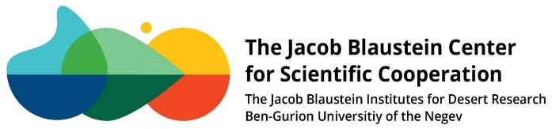

Application form for BCSC support of scientific international events

(Before completing, please review the Guidelines for Funding at the BCSC website)

- Organizer: Click or tap here to enter text.

- Department/Institute: Click or tap here to enter text.

- Topic: Click or tap here to enter text.
- The significant contribution of the event to BIDR: Click or tap here to enter text.

- Invited international keynote speakers who have expressed interest in attending and the tentative titles of their lectures: Click or tap here to enter text.
- Invited local keynote speakers who have expressed interest in attending and the tentative titles of their lectures: Click or tap here to enter text.
- Parallel sessions: dates and topics/tentative titles of lecturers (not required for kickoff/status meeting):

- Approximate number of participants: Click or tap here to enter text.

- Date of the event: Click or tap here to enter text.

- Location: Click or tap here to enter text.

Please attach (in English):
- Detailed program
- Detailed budget
- A list of invited participants who have confirmed their attendance, and the tentative titles of their lectures.

Please send all materials to inter@bgu.ac.il
NOTE:
If funded, the logo of the “Jacob Blaustein Center for Scientific Cooperation” is required to appear on all publications related to the event.

