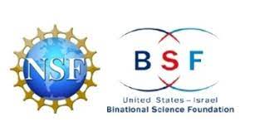

NSF-BSF Joint Funding Research Grants

Foundation Name: NSF-BSF Joint Funding Research Grants
Country of Origin: USA and Israel
Website: https://www.bsf.org.il/funding-opportunities/nsf-bsf-joint-research-grants/the-programs/
General Information: In 2012, the BSF signed an umbrella Memorandum of Understanding with the U.S. National Science Foundation (NSF), for cooperation in joint funding of collaborative U.S.-Israeli scientific research. Consequently, the BSF signed a series of specific Memorandum of Understanding (MOU) and Letter of Intent (LOI) with a number of NSF units, for the joint funding of collaborative research programs.
Focus Areas: All disciplines
special points: There are calls with deadline and calls with open deadline.
Financial support for the U.S. scientists in the joint NSF-BSF funding programs comes from the internal resources of the NSF, as part of its regular activity.
Financial support for the Israeli scientists in these programs is from annual allocations from the Israeli Committee for Planning and Budgeting (CPB). CPB funds are specifically to support the Israeli researchers in the NSF-BSF programs, and they do not affect the traditional BSF programs.

