**Training Protocol for 302 Resistivity Probe Stand:**

Training protocol on four-point resistivity and conductivity type measurements.

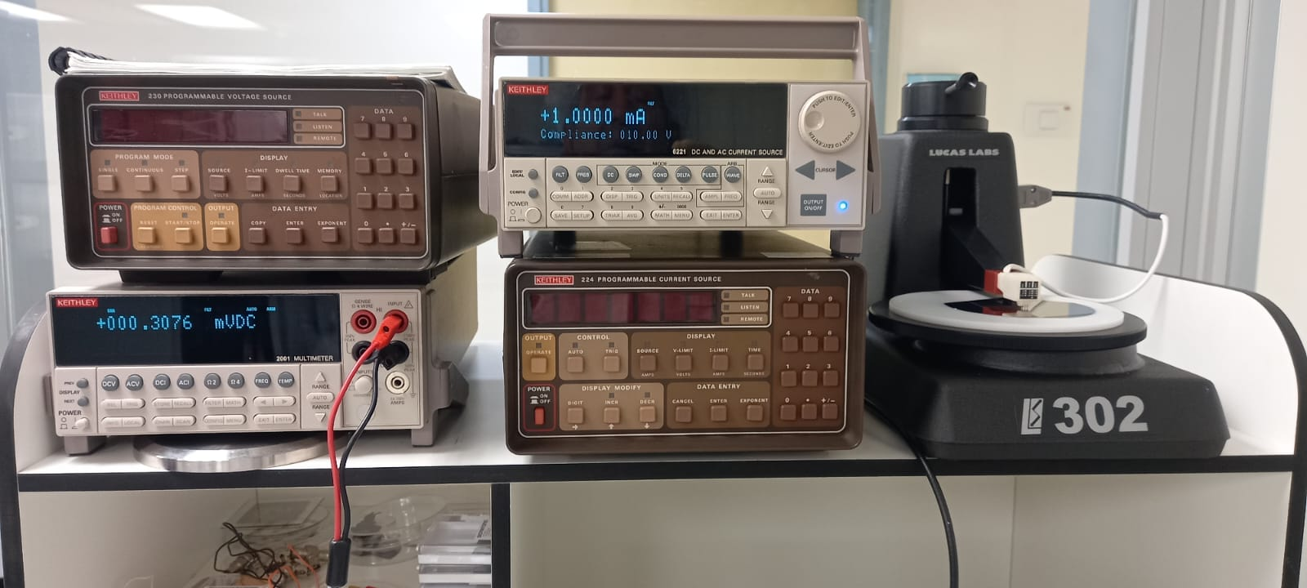

Purpose:

To determine the resistivity of a substrate or a thin film by using the four-point probe, current source, and Keithley 2001 multimeter.

Preparation:

1. Turn on the Keithley 6221current source and Keithley 2001 multimeter.
2. The multimeter should power in the DCV mode.
3. On the current source enter the desired current and press OUTPUT button.
4. Place the test sample on the teflon disk and center the sample under the probe head.
5. Lower the probe head by moving the top lever clockwise noting that the probe tips making contact with the sample. (the output LED does not flash)
6. Read the voltage, shown on the multimeter.
7. Sheet resistance is given by:

Rs = p/t= k $V/I$

Where p is the resistivity, t is the thickness of the sample (film), and K is the sheet resistance correction factor which depends on the shape of the sample, its thickness, and the probe tip spacing.