sample abstract template:
A Status Report from the Field

David Faiman¹, Dov Bukobza¹, Shlomo Kabalo¹, and Edwin de Held²

¹Dept. of Solar Energy, Blaustein Inst. for Desert Research, Ben-Gurion Univ. 849000, Israel
²NKF, P.O. Box 26, 2600 MC Delft, The Netherlands

ABSTRACT
This template is intended to provide authors with a general framework for submitting abstracts, which will give our Proceedings book an aspect of uniformity.
General Instructions - (which is how this template is set up already)
- Abstract length: 1 page maximum
- Word File (not PDF)
- Font: Times New Roman
- Font size: 12 preferred (10 or 11 if you need to fit your entire paper in 1 page)
- Page set-up:
  - Margins: Top - 3; Bottom - 2.5; Sides - 2.2; Header - 1; Footer – 1.2
  - Paper size: A4
- File name: Main author's last name then 1 or 2 keywords from Title (e.g. Faiman Sample abstract)
- Graphics and Photos: only those that copy well in Black and White (Grayscale)
- Figures, Tables etc. preferably within the text along with their legend. Headings, References and other style issues: at your discretion

WHEN SUBMITTING YOUR ABSTRACT, PLEASE INDICATE IN YOUR EMAIL WHETHER YOU ALLOW US TO UPLOAD YOUR PRESENTATION TO THE CONFERENCE WEBSITE AFTER THE SYMPOSIUM.

SAMPLE TEXT IS SHOWN BELOW

1. INTRODUCTION
Amorphous silicon (a-Si) and crystalline silicon (c-Si) solar cells have different spectral responses owing mainly to the different band gaps of the two materials. This is readily apparent if ….

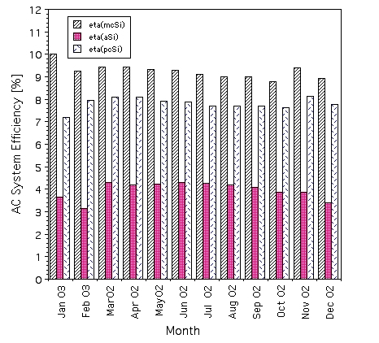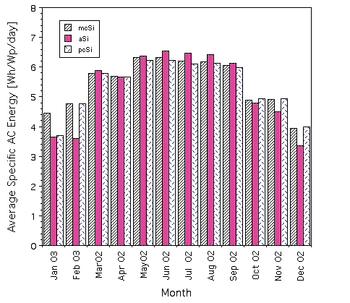
Figure 1: Monthly mean (a) efficiency, (b) specific AC energy output [Wh/Wp/day]
for the 3 systems under test at Sede Boqer.

Fig. 1b displays the corresponding specific energy outputs of the three systems. Here, all systems are seen to have comparable performances but with the a-Si system slightly outperforming both of the c-Si systems during the summer months, albeit yielding a lower output during the winter months.

4. ACKNOWLEDGMENTS
This work was partially funded by the Israel Ministry of …. The authors wish to thank …

REFERENCES
[1] D. Berman, D. Faiman and B. Farhi, Sinusoidal spectral correction for high precision outdoor module characterization, Sol. En. Mater. Sol. Cells 58 (1999) 253-264.

Corresponding author, e-mail address, phone number

