Yair Kaufman’s Group: Studying the Molecular Interactions/Forces that Occur at the Interface

Overview
Kaufman’s group is studying the molecular interactions between interfaces. These molecular interactions determine the lateral forces (friction) and the vertical forces (adhesion/repulsion) between interfaces. The strength of the adhesion/repulsion between two macroscopic interfaces is manifested in many ways; for instance, it determines whether liquids spread or "pinned" on surfaces (see "Surface Wetting" below), or whether a lipid membrane can self-assembled and form a biomimetic membrane on a surface (see "Biomimetic Membranes" below).
Currently, the group is focusing on three different, yet related projects. (1) We measure and model the ability of liquids to spread on smooth or nano-textured/roughened surfaces. (2) We also study biological membranes and the formation of biomimetic membranes on different surfaces. These biomimetic membranes can be used as a selective barrier, e.g., for filtration. Biomimetic membranes can also be used as an indicative barrier, e.g., for bio sensors, or in some cases they can prevent the adhesion of bacteria and serve as an ‘anti-biofilm’ layer. The group is also developing new functionalities to atomic force microscopes; functionalities that will allow us to measure the absolute distance and the contact area between the probe of atomic force microscope and a surface. These two parameters, absolute distance and contact area, are crucial for shedding-light on the molecular interactions between interfaces.

(1) Effect of surface texture/roughness/pattern on the ability of liquids to spread on the surface
Controlling the metastable and the thermodynamically stable macroscopic contact angle, whether above or below the intrinsic contact angle is desirable for many applications. These applications include non-wetting, self-cleaning and anti-fouling surfaces, or completely-wetting/spreading applications, such as cosmetics and lubricant fluids. As demonstrated in Fig. 1, we study the effect of nano/micro textures on the liquid-solid molecular interactions, which are manifested in the apparent contact angles.
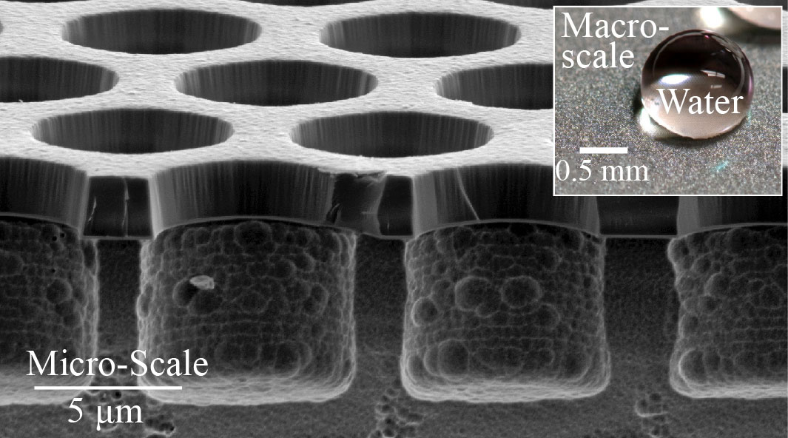
Figure 1: We study the effects of nano/micro textures on the molecular interactions between liquids and solids. These molecular interactions determine whether a droplet spread or ‘pin’ on a surface.

(2) Supported and non-supported biomimetic membranes: Fundamentals and applications
Biological membranes consist of variety of lipids, proteins, and peptides. These membranes carry out vast number of roles. For instance, (1) they selectively transport molecules into and out of the cells; (2) biological membranes detect signals from the cell surrounding, such as light and mechanical stresses, and ‘inform’ the cell about these signals; in addition, (3) they can adhere to other cells for different purposes, such as communications.
In our group, using atomic force microscopy (AFM) and other techniques, we study the interactions among the lipids in biomimetic membranes and the interactions between lipids and proteins. We also study the interactions between lipids and protein to different surfaces. Then we explore the possibility of applying this knowledge for different applications, such as water purification, anti-fouling applications and more.

(3) Introducing new functionalities to atomic force microscopy (AFM)
The state of the art AFMs today do not allow for measuring (1) the absolute distance between the AFM probe and the surface that is being studied, nor (2) the contact area between the probe and the surface. Both parameters are crucial for studying the molecular interaction between surface. To address these challenges, we are developing a new extension for AFMs.

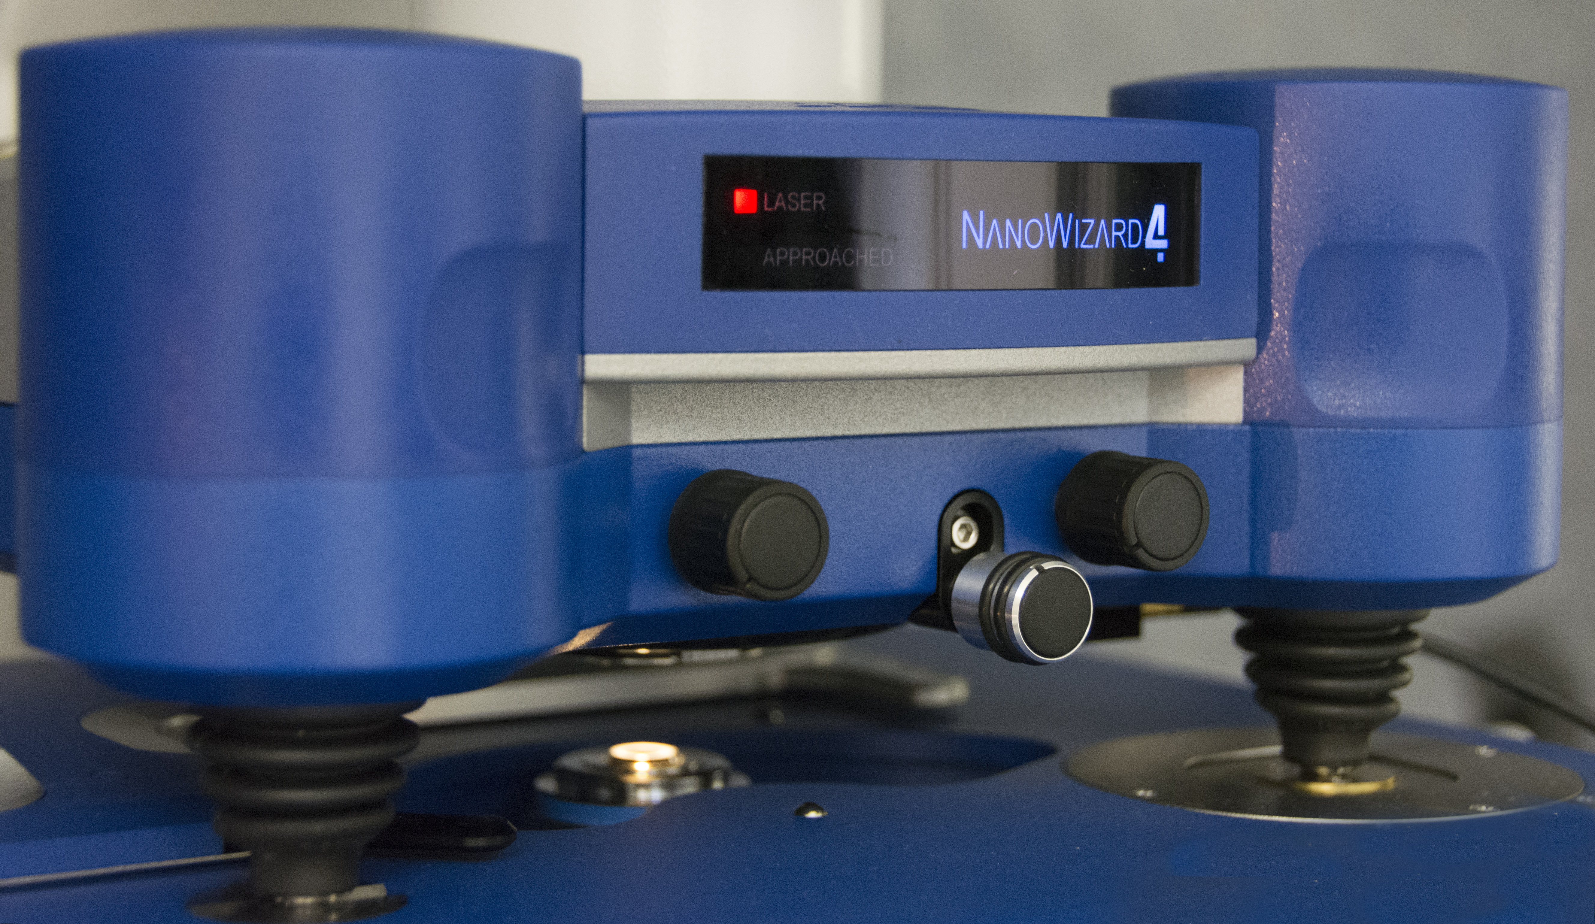
Figure 2: The picture shows the atomic force microscope (AFM) we use in our lab to measure the interactions between surfaces and to image surfaces at the nano-metric level. This AFM is coupled (not shown in the picture) with inverted and upright fluorescence microscopes. In addition, it allows for controlling the sample temperature while the sample is soaked in liquid. Our AFM setup also allows for applying electric potentials to the probe and the surface, i.e., the setup allows for conducting electro-chemistry experiments while ‘imaging’ the surface.

