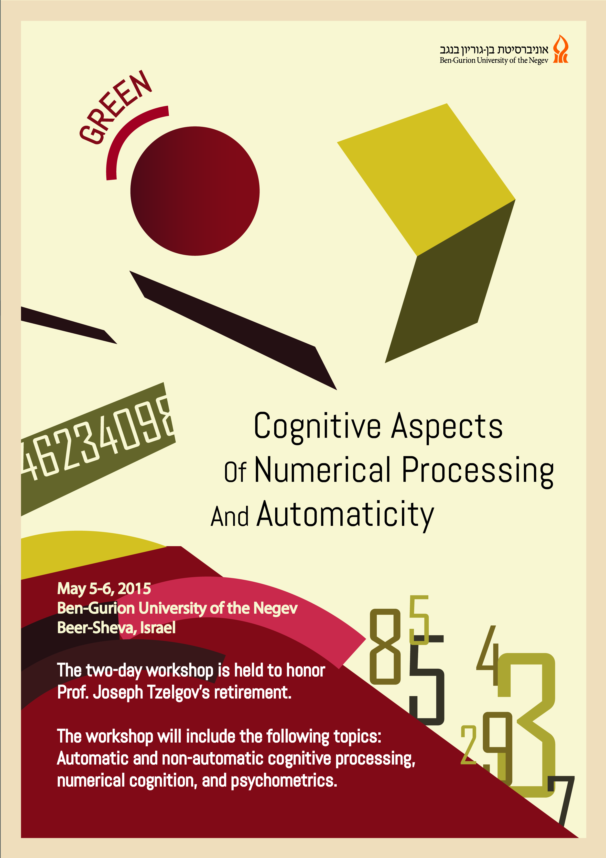
A workshop in honor of Prof. Joseph Tzelgov's retirement will take place May 5-6, 2015 at Ben-Gurion University of the Negev, Beer-Sheva, Israel. The workshop will start in the afternoon of Tuesday May 5th.
The international workshop is entitled Cognitive Aspects of Numerical Processing and Automaticity. The themes covered in the workshop include: (1) Automatic and non-automatic cognitive processing; (2) Numerical cognition; and (3) Psychometrics.

Speakers include, among others, Prof. Gordon Logan, Prof. Emmanuel Pothos, Dr. Yoav Cohen, and Dr. Dana Ganor.

Attendance is free but we ask everyone to register in advance so we can prepare for the size of the audience. To proceed to the registration page click here (note, if the link does not work, please go to http://goo.gl/P04Aqm to register).
For additional information or inquiries, address correspondence to Ms. Desiree Meloul at desiree@bgu.ac.il

